**VISVESVARAYA TECHNOLOGICAL UNIVERSITY**

**“JnanaSangama”, Belgaum -590014, Karnataka.**

**L**

**AB REPORT**



**ON**

**MACHINE LEARNING**

***Submitted by***

# MANASA SRIRAMAIAH(1BM21CS101)

***in partial fulfillment for the award of the degree of***

**BACHELOR OF ENGINEERING**

***in***

**COMPUTER SCIENCE AND ENGINEERING**



**B. M. S. College of Engineering,**

**Bull Temple Road, Bangalore 560019**

**(March 2024 to June 2024)**



**B. M. S. College of Engineering,**

**Bull Temple Road, Bangalore 560019**

(Affiliated To Visvesvaraya Technological University, Belgaum)

## Department of Computer Science and Engineering

**CERTIFICATE**

This is to certify that the Lab work entitled “**MACHINE LEARNING**” is carried out by **MANASA SRIRAMAIAH (1BM21CS101)** who is bonafide student of **B.M.S. College of Engineering.** It is in partial fulfillment for the award of **Bachelor of Engineering in Computer Science and Engineering** of the Visveswaraya Technological University, Belgaum during the year 2023-2024. The lab report has been approved as it satisfies the academic requirements in respect of **Machine Learning Lab - (22CS3PCMAL)** work prescribed for the said degree.

**Prof. Sunayana S Dr. Jyothi S Nayak** Assistant Professor Prof.& Head, Dept. of CSE BMSCE, Bengaluru BMSCE, Bengaluru

**INDEX**

|  |  |  |
| --- | --- | --- |
| **Sl.**  **No.** | **Experiment Title** | **Page No.** |
| 1 | Write a python program to import and export data using Pandas library functions | 4 |
| 2 | Demonstrate various data pre-processing techniques for a given dataset | 7 |
| 3 | Use an appropriate data set for building the decision tree (ID3) and apply this knowledge to classify a new sample. | 10 |
| 4 | Build KNN Classification model for a given dataset. | 14 |
| 5 | Implement Linear and Multi-Linear Regression algorithm using appropriate dataset | 21 |
| 6 | Build Logistic Regression Model for a given dataset | 28 |
| 7 | Build Support vector machine model for a given dataset. | 38 |
| 8 | Build k-Means algorithm to cluster a set of data stored in a .CSV file. | 44 |
| 9 | Implement Dimensionality reduction using Principle Component Analysis (PCA) method. | 48 |
| 10 | Build Artificial Neural Network model with back propagation on a given dataset | 52 |
| 11 | 1. Implement Random forest ensemble method on a given dataset. 2. Implement Boosting ensemble method on a given dataset. | 56 |

**COURSE OUTCOME:**

|  |  |
| --- | --- |
| CO1 | Apply machine learning techniques in computing systems |
| CO2 | Evaluate the model using metrics |
| CO3 | Design a model using machine learning to solve a problem |
| CO4 | Conduct experiments to solve real-world problems using appropriate machine learning techniques |

**Program 1**

**Write a python program to import and export data using pandas library functions?**

**Code:**

**Import**

import pandas as pd

airbnb_data = pd.read_csv("listings (1).csv")

airbnb_data.head()

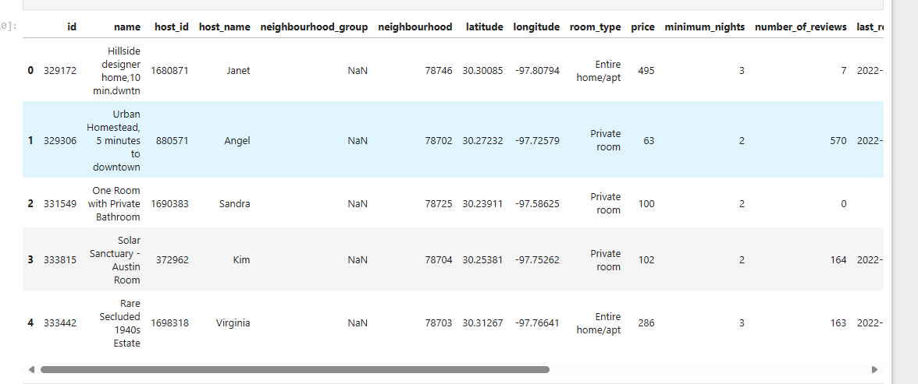

**Export**

airbnb_data.to_csv("list2.csv")

**Reading the file from the URL:**

url = "https://archive.ics.uci.edu/ml/machine-learning-databases/iris/iris.data"

col_names = ["sepal_length_in_cm",

"sepal_width_in_cm",

"petal_length_in_cm",

"petal_width_in_cm",

"class"]

iris_data = pd.read_csv(url, names=col_names)

iris_data.head()

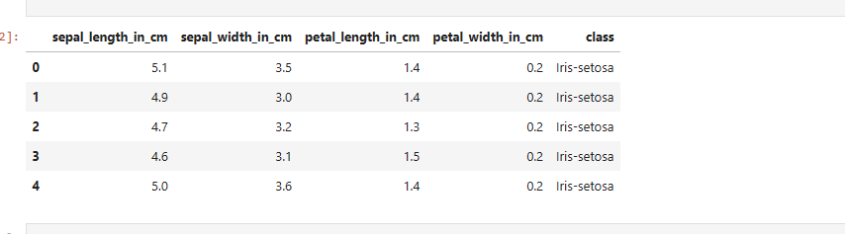

**Program 2**

Use an appropriate data set for building the decision tree (ID3) and apply this knowledge to classify a new sample.

1.importing database

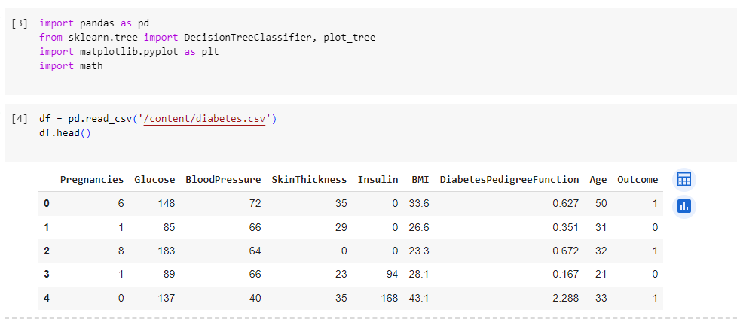

2.Calculating entropy and information gain.

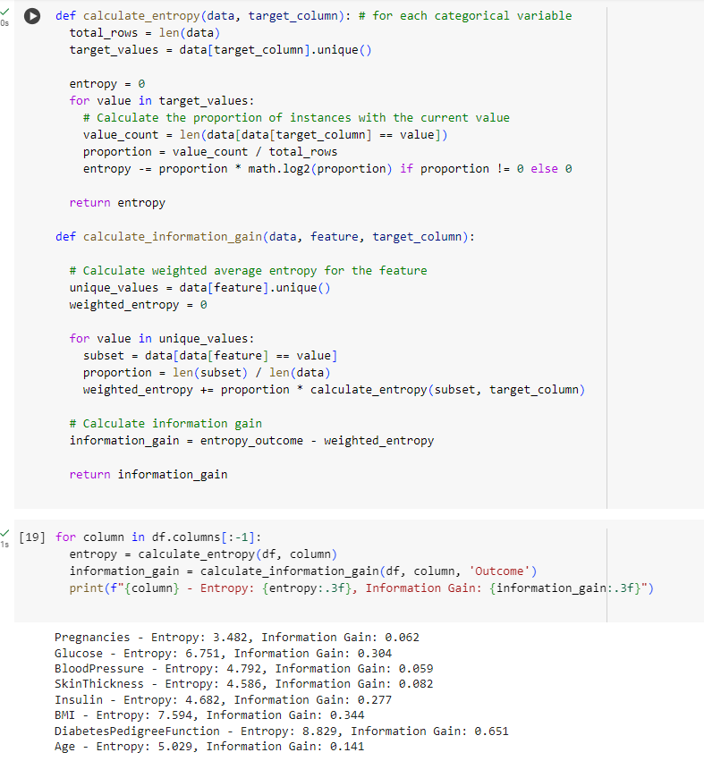

3.Making Decision tree.

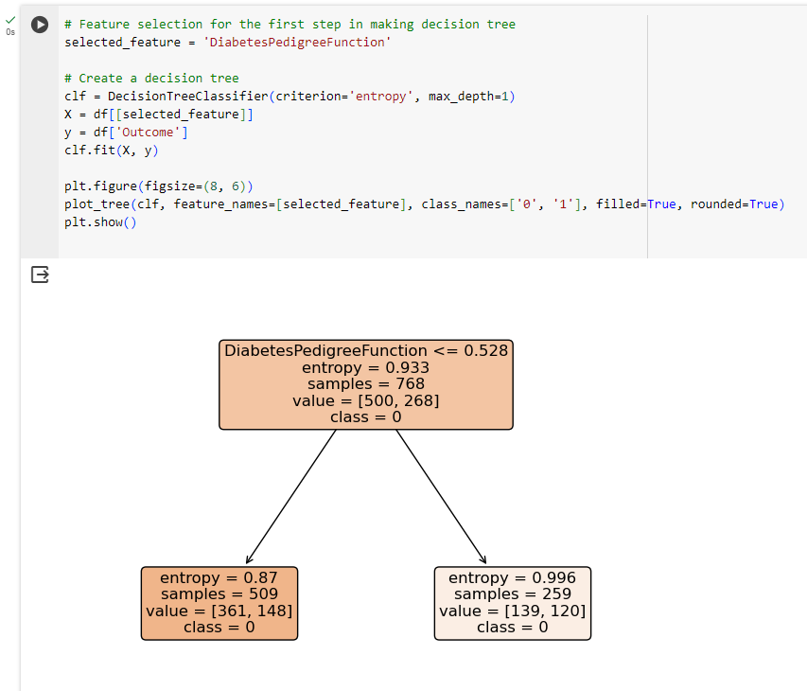

**Program 3**

a)Implement Linear Regression algorithm using appropriate dataset

Code and output:

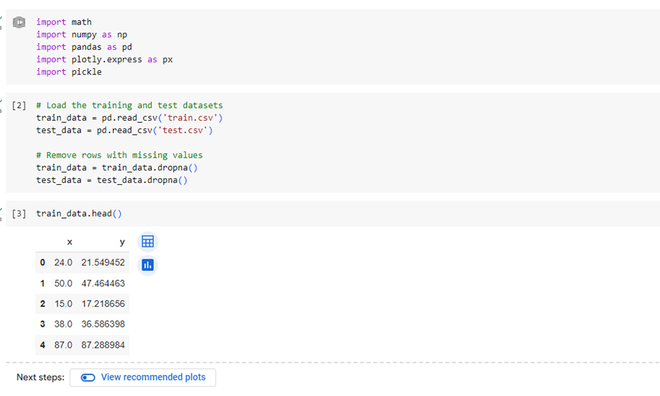

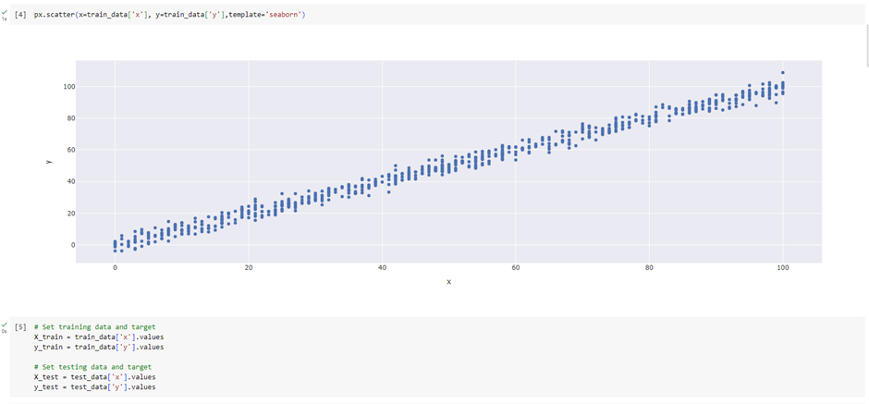

b)Implement Multi-Linear Regression algorithm using appropriate dataset

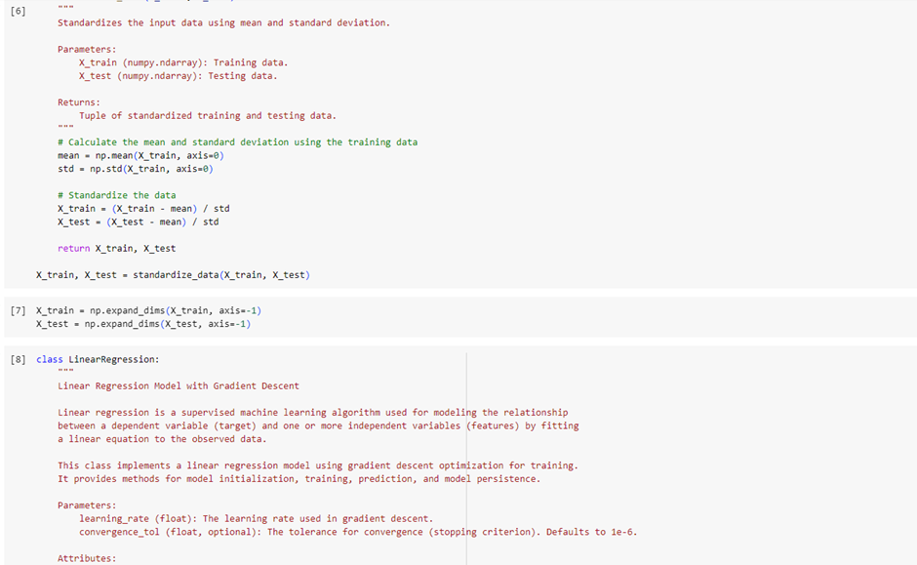

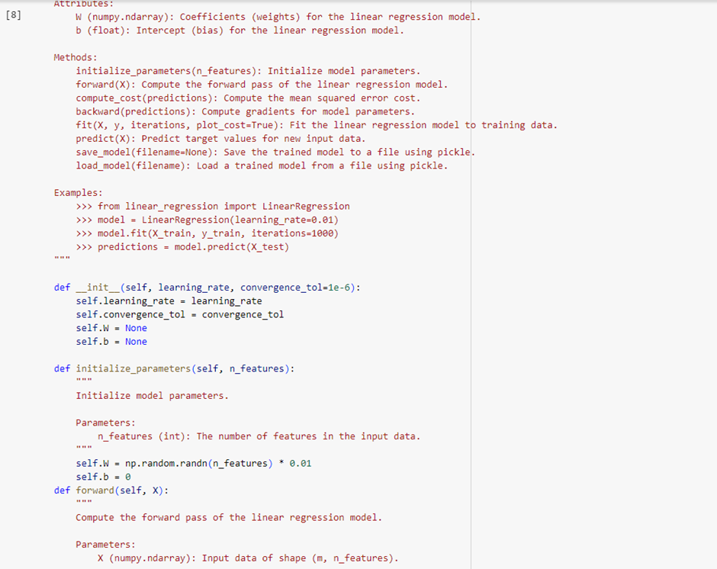

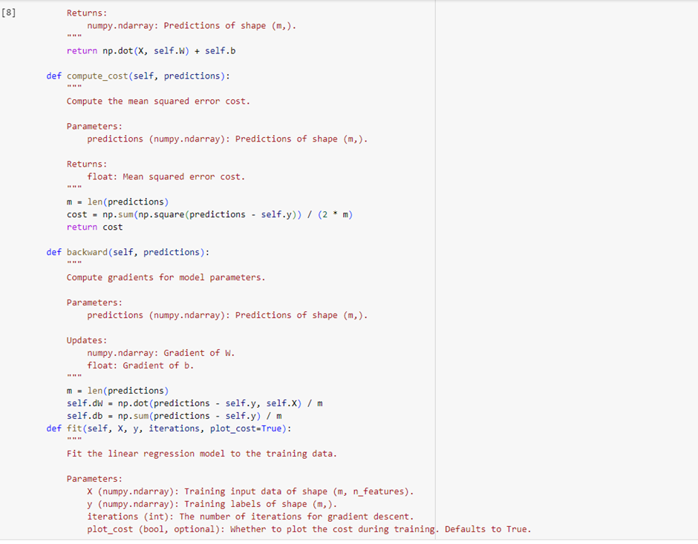

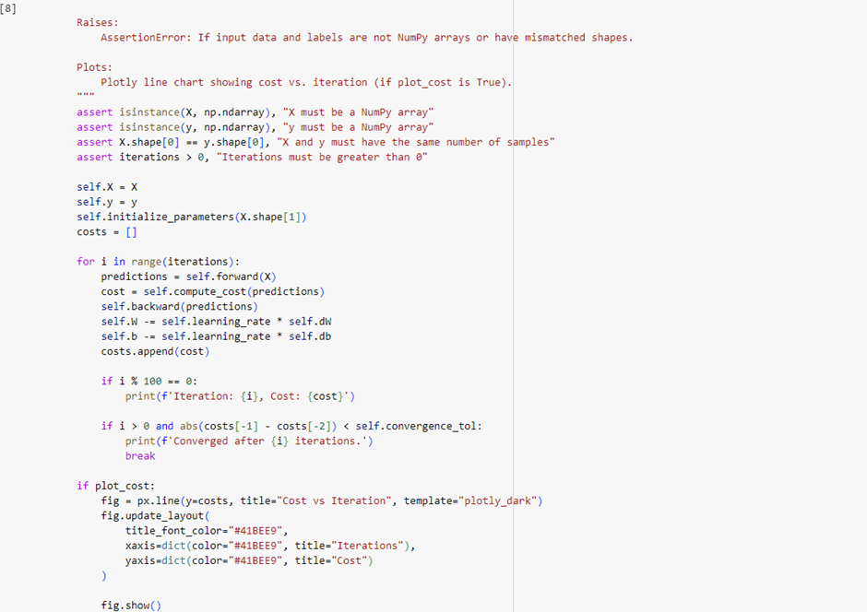

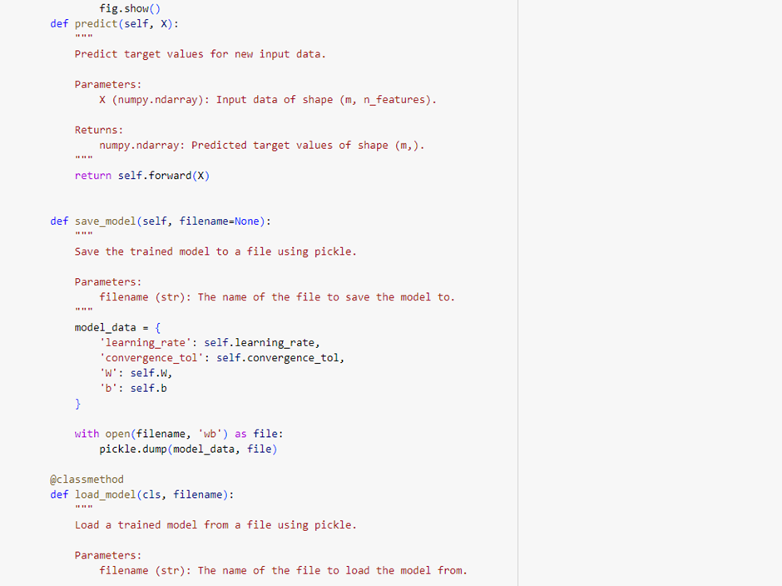

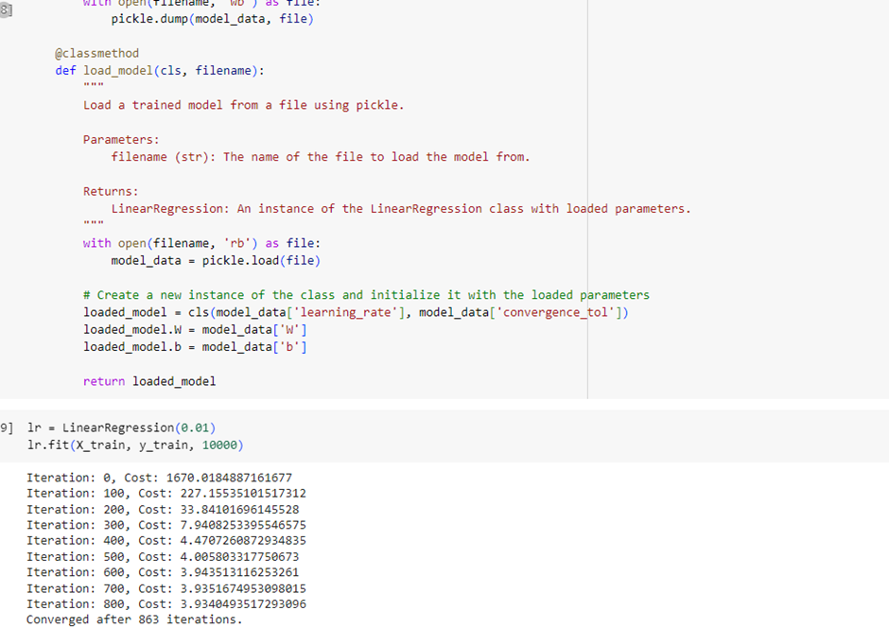

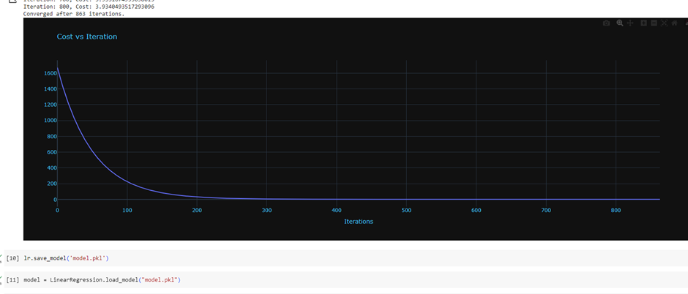

c)Build KNN Classification model for a given dataset.

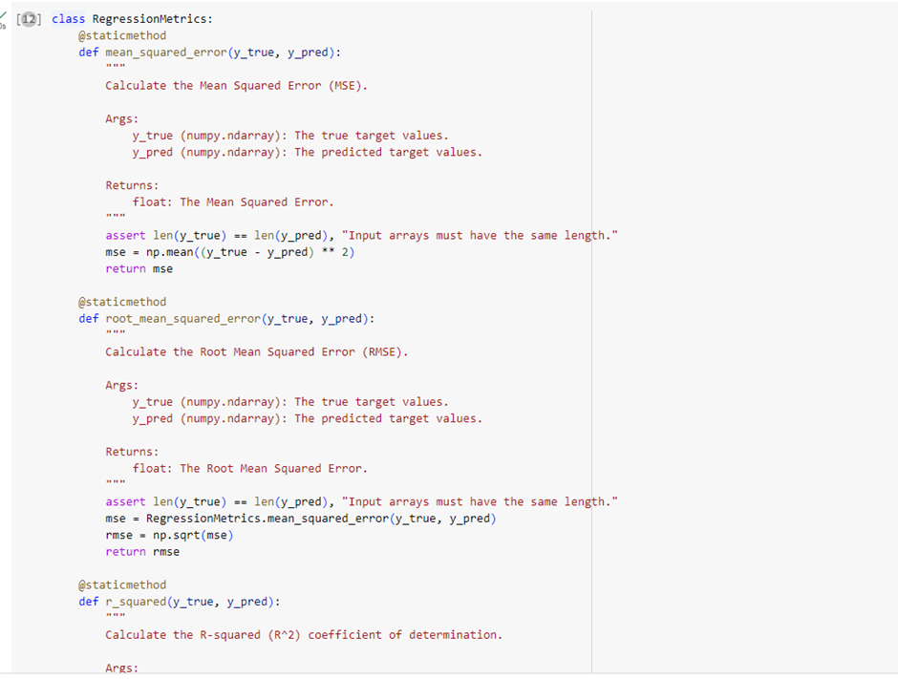

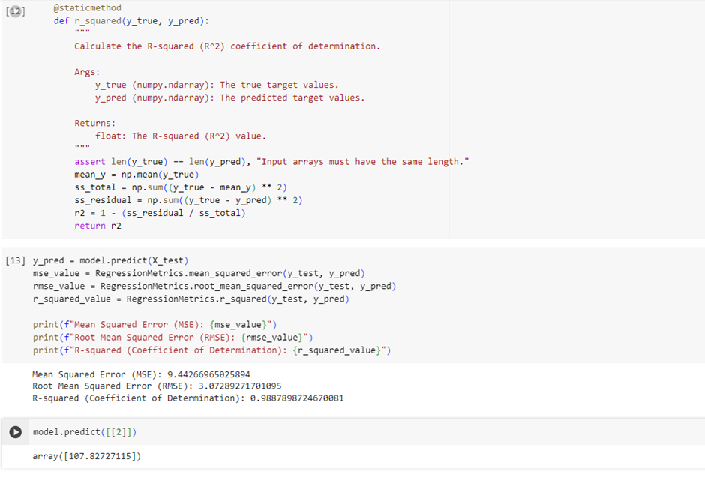

**Program 3**

1. Build Logistic Regression Model for a given dataset

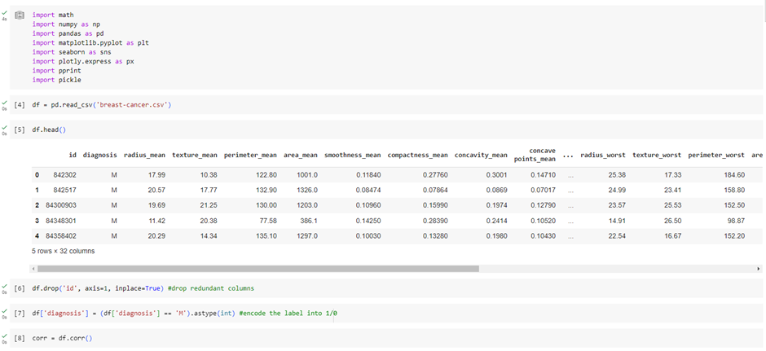

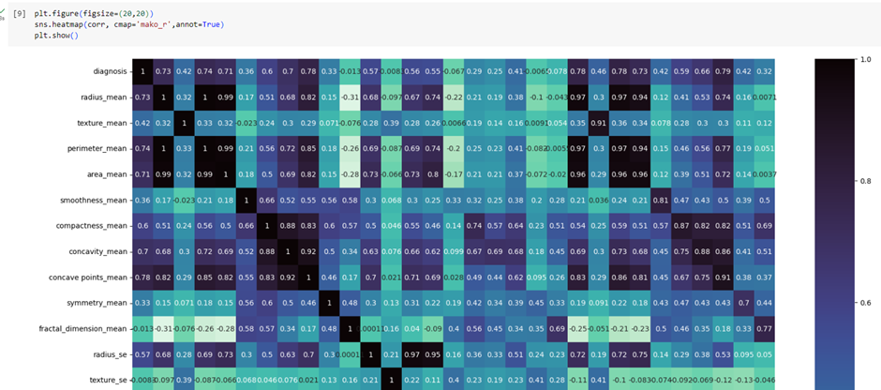

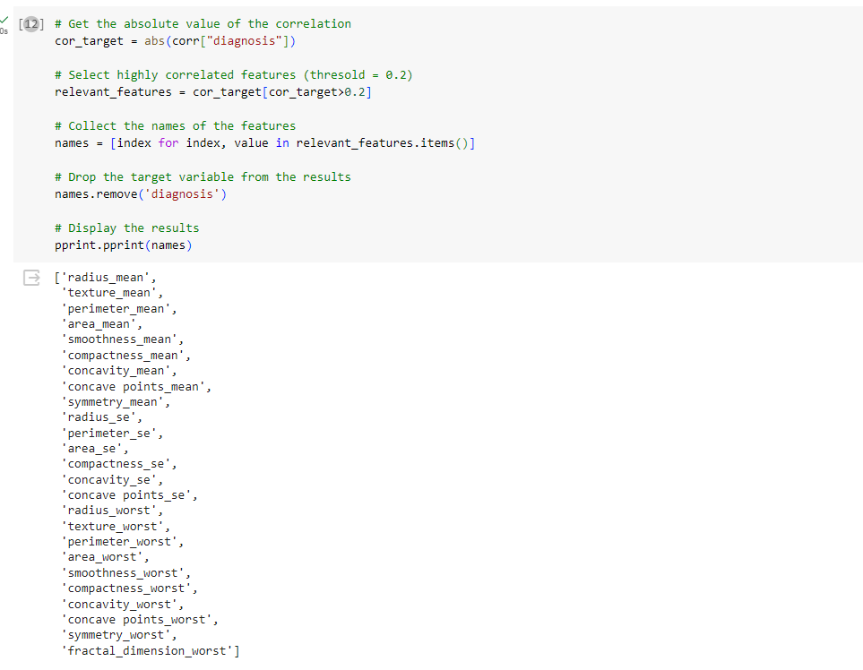

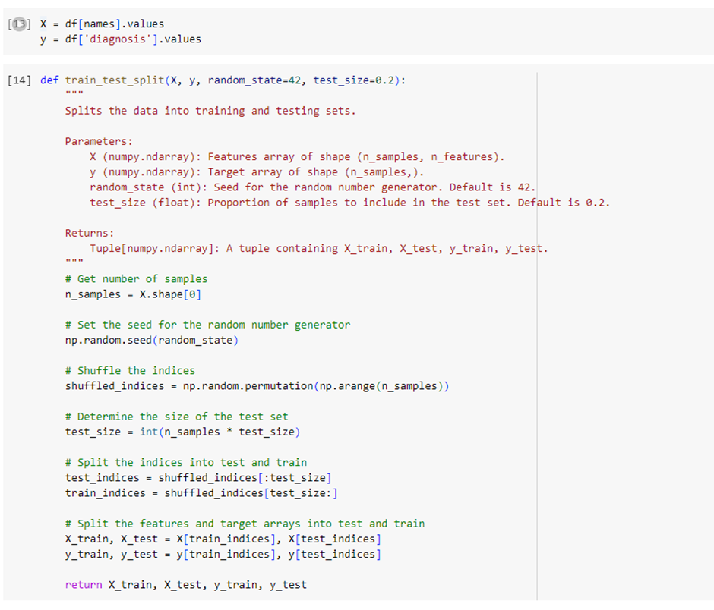

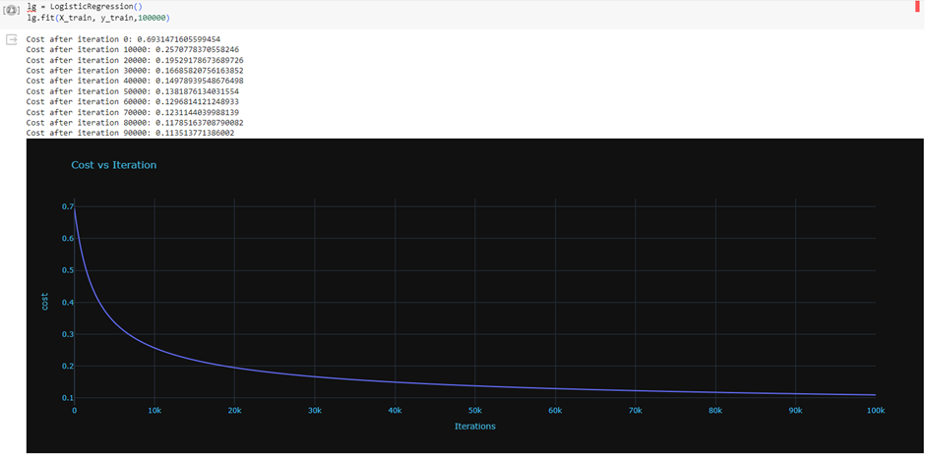

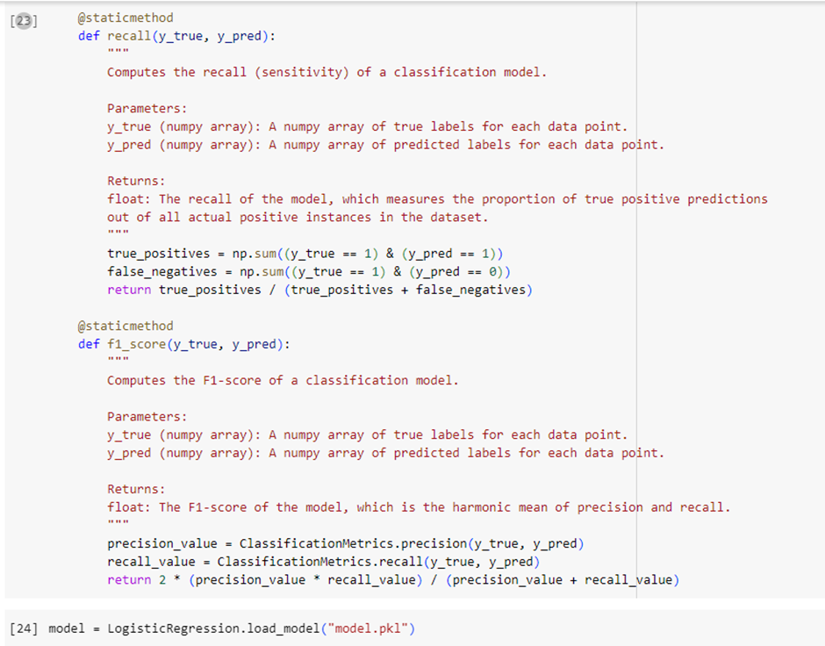

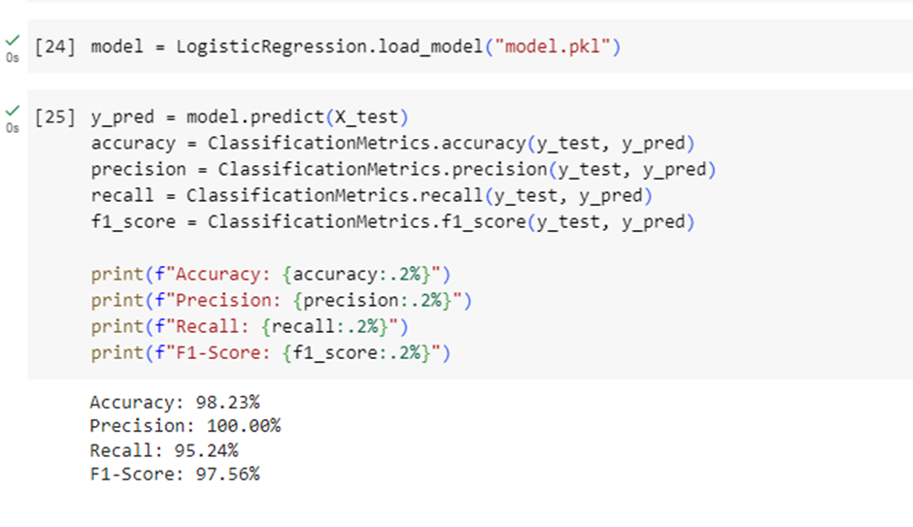

**Program 4**

1. Build Support vector machine model for a given dataset.

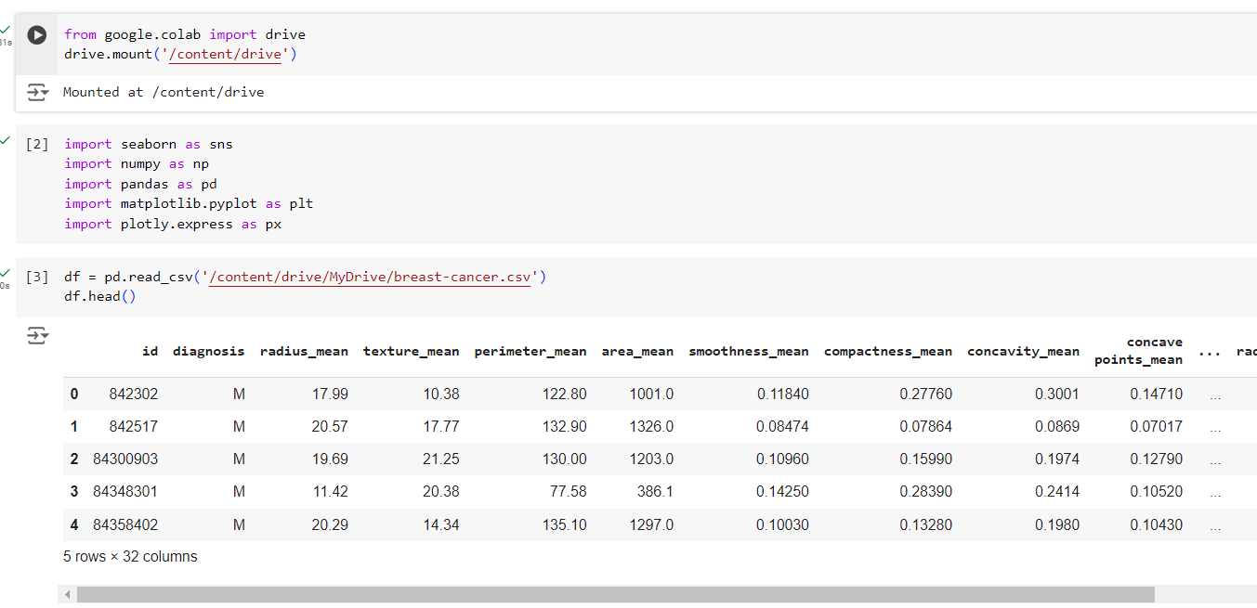

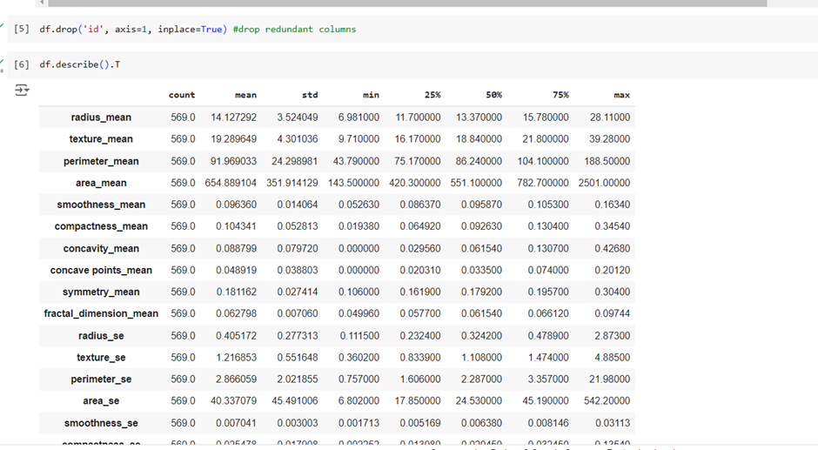

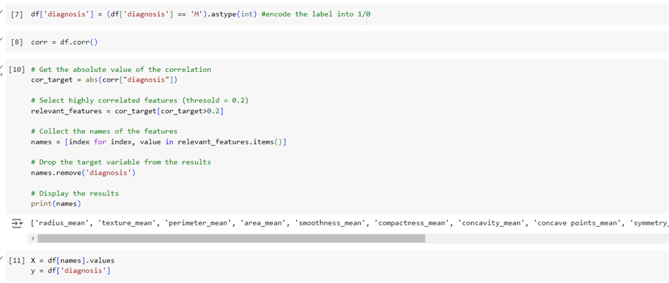

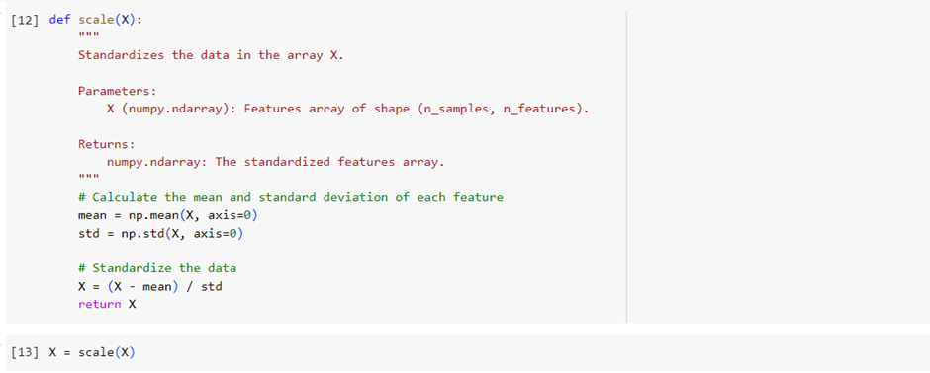

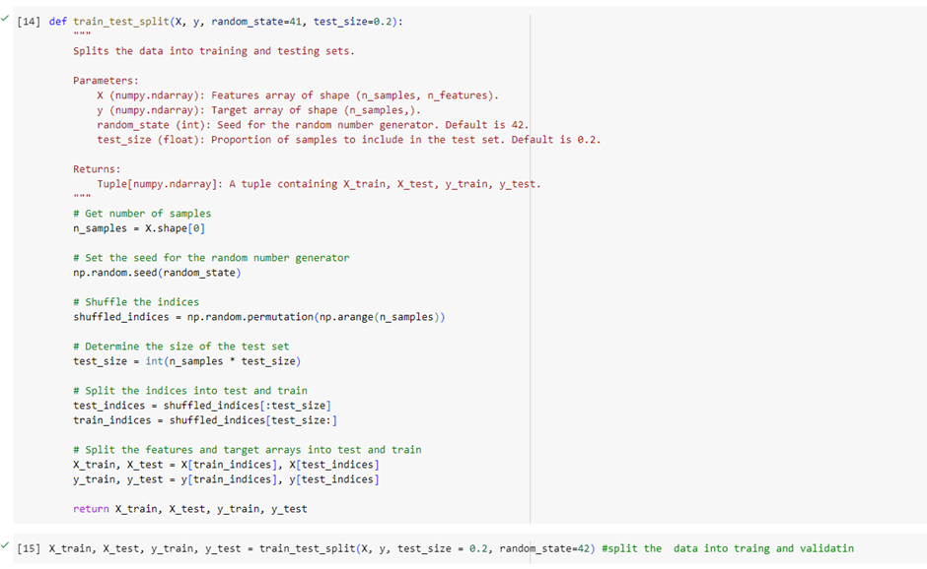

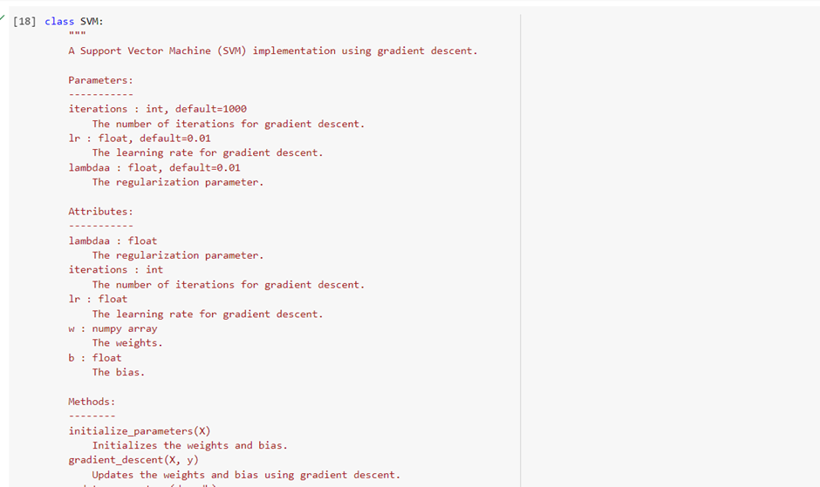

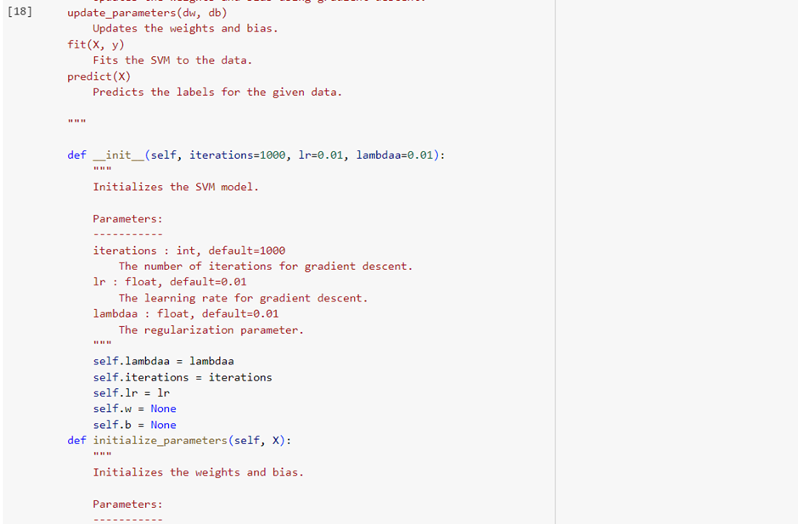

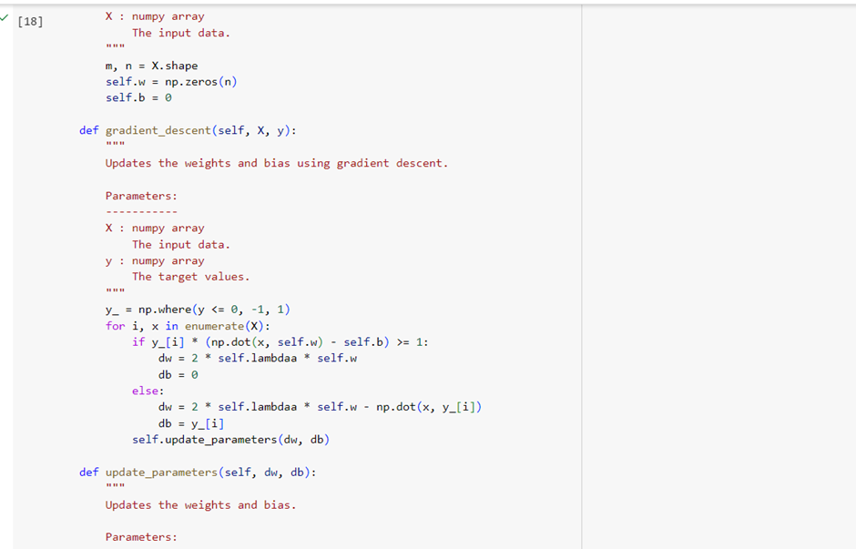

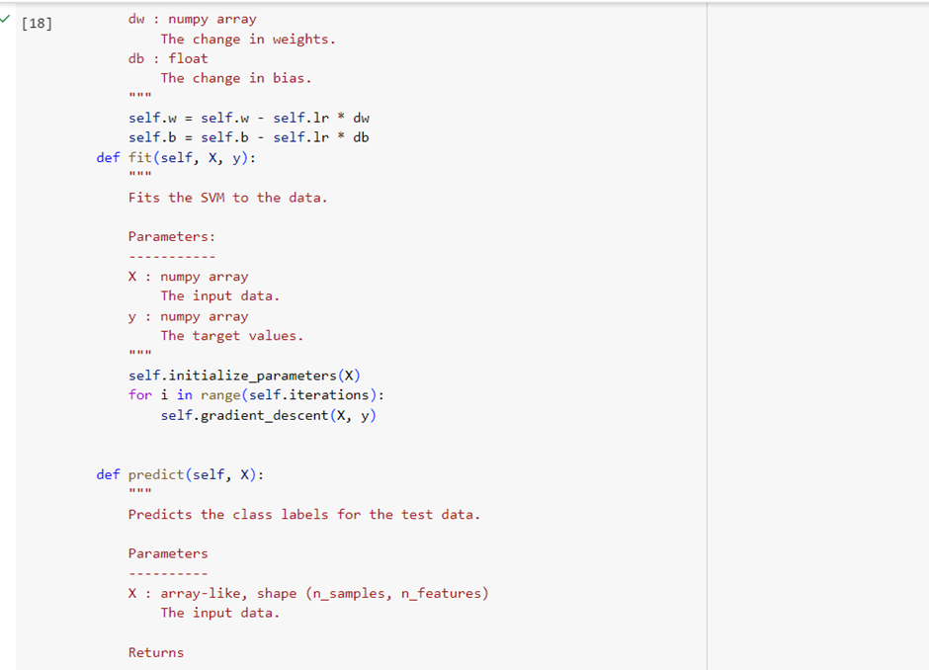

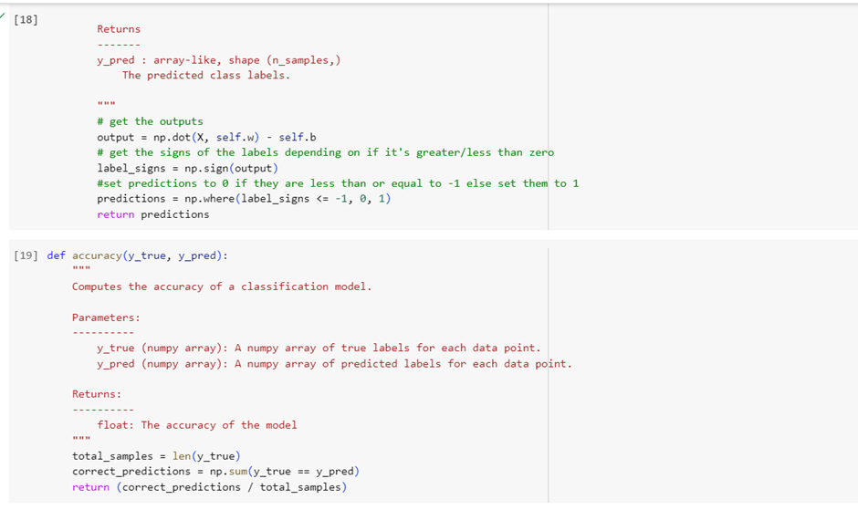

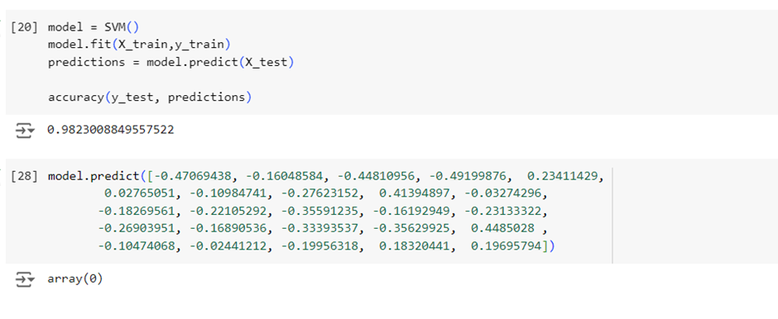

**b)Build k-means algorithm to cluster a set of data stored in a .CSV file.**

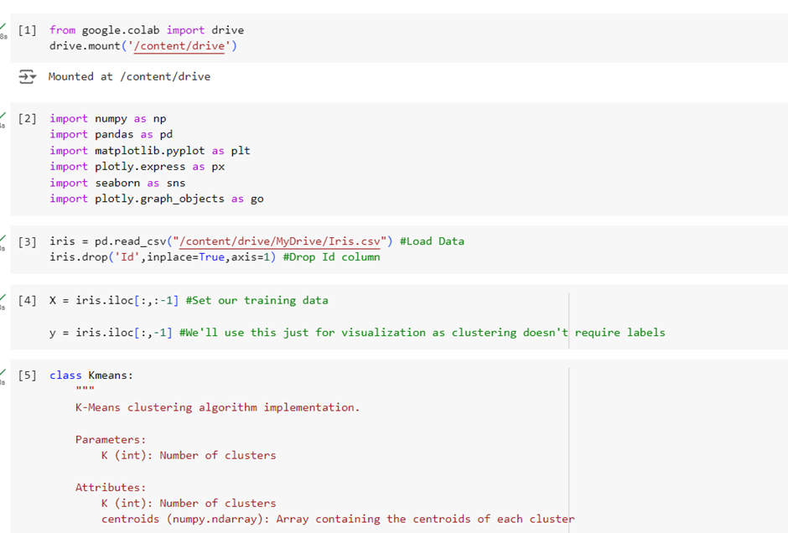

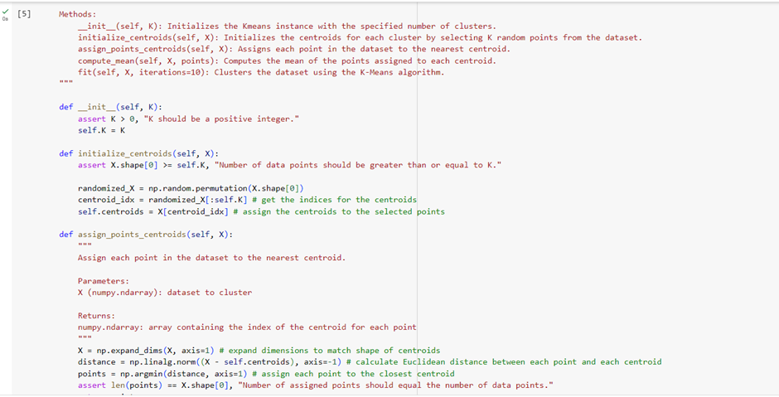

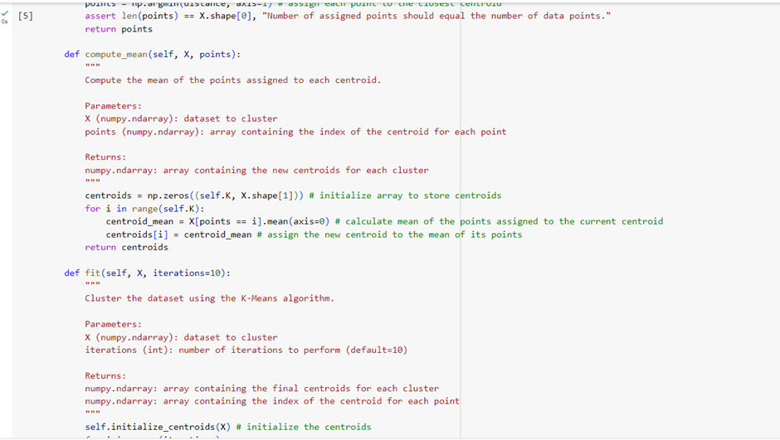

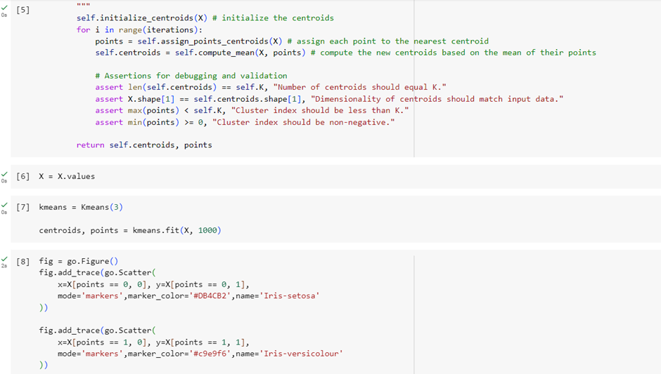

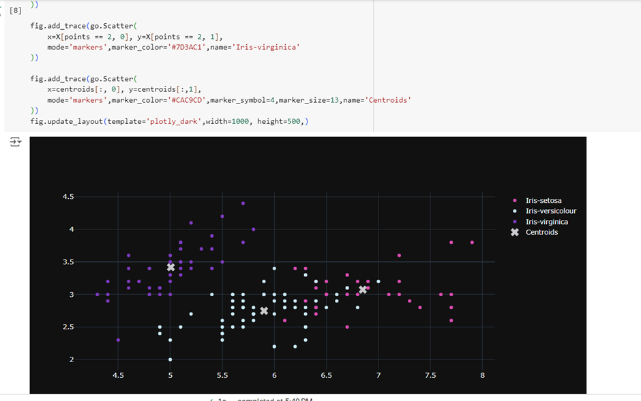

**c)Implement dimensionality reduction using principle component analysis (PCA).**

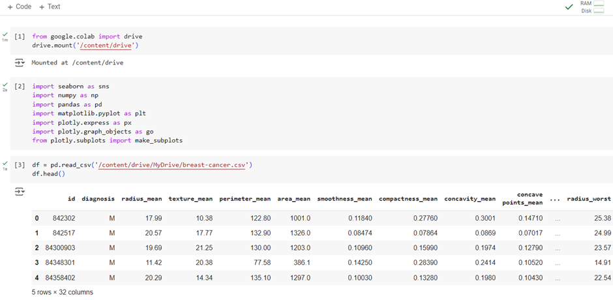

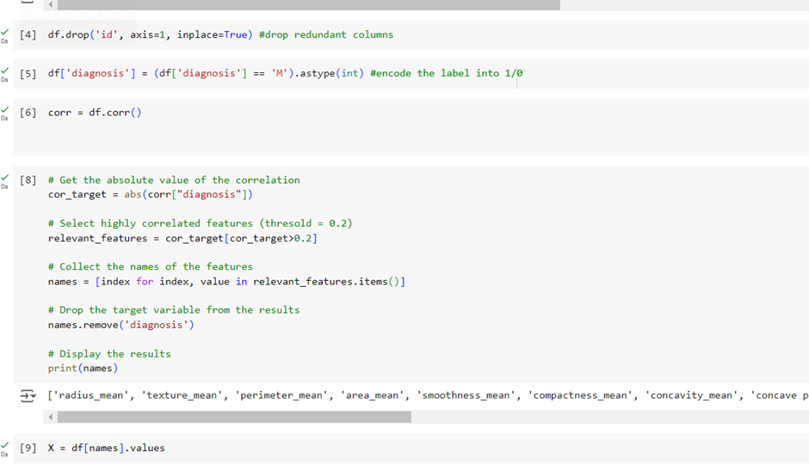

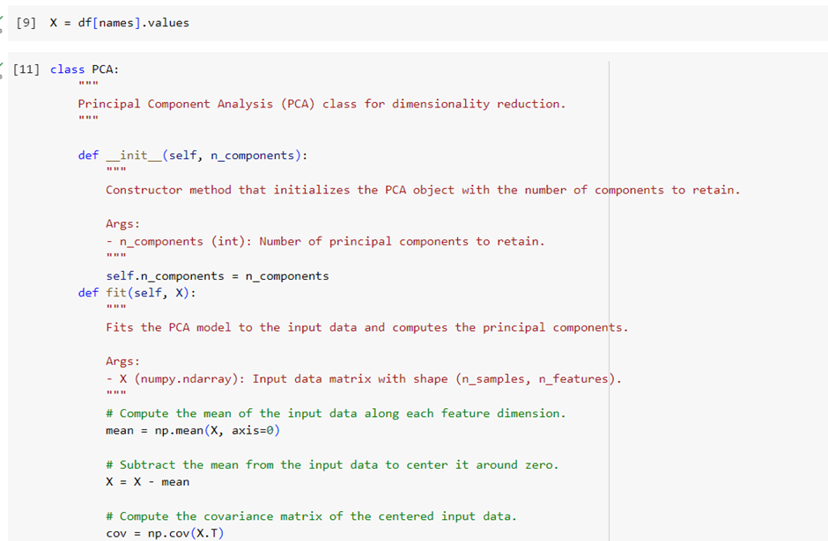

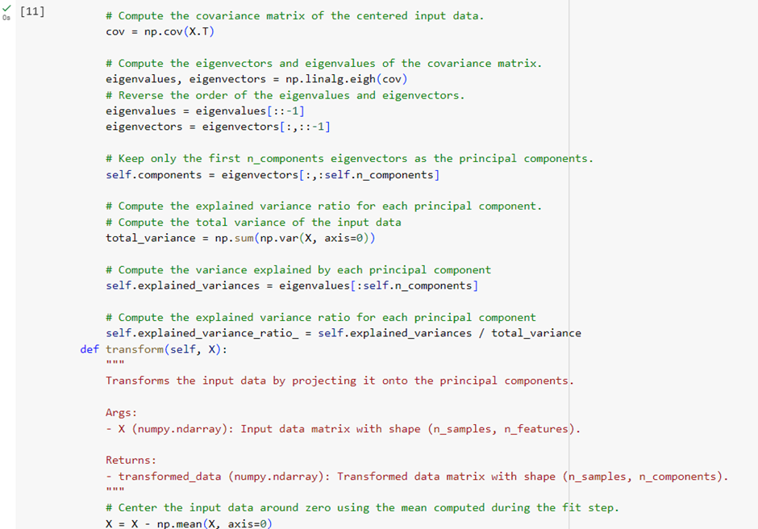

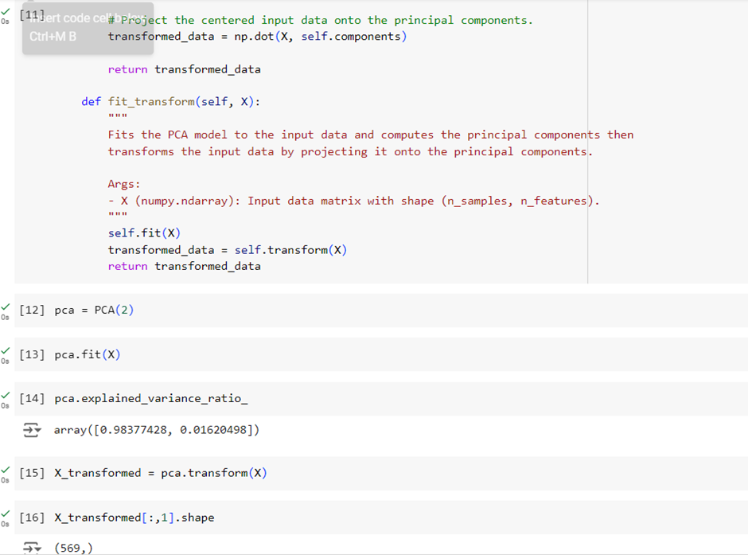

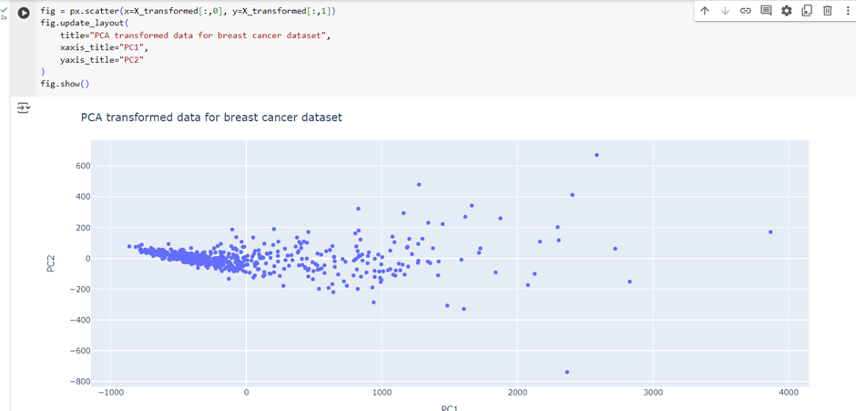

**Program 5**

1.Build Artificial Neural Network model with back propagation on a given dataset.

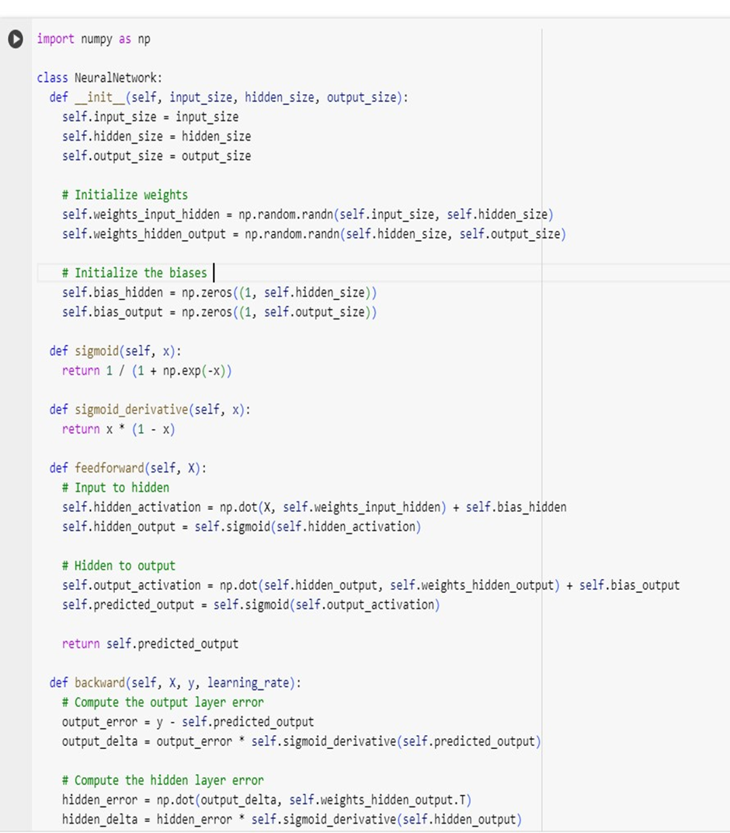

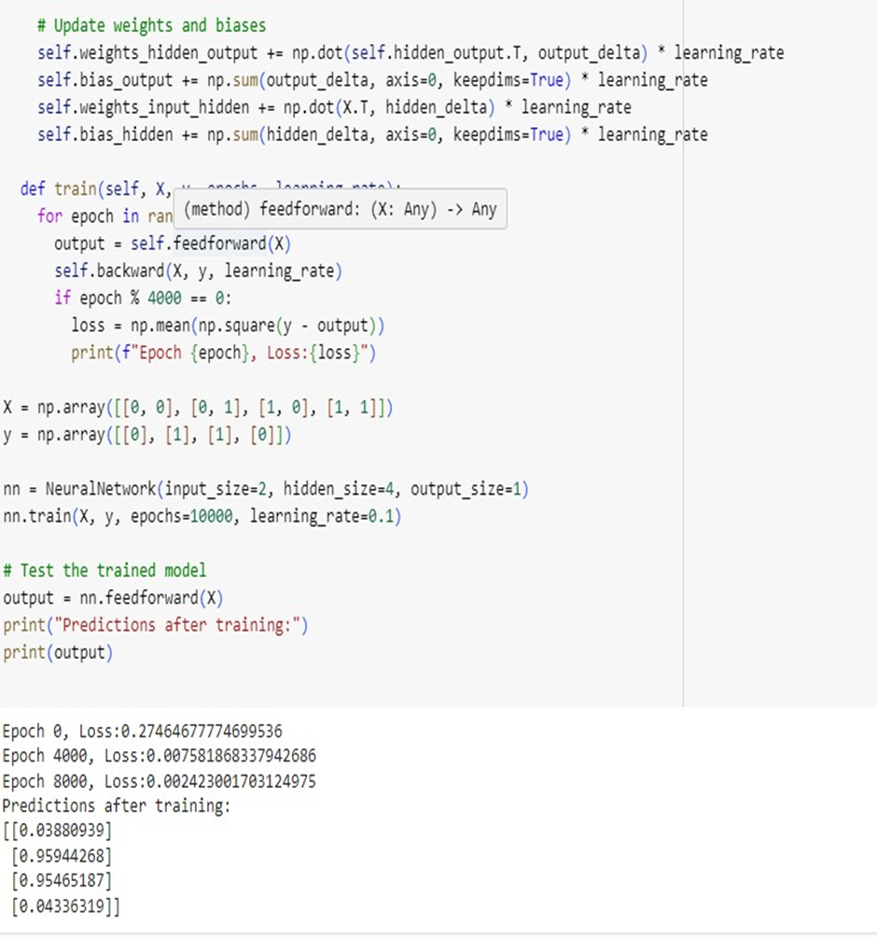

Program 6

1.Implement Random Forest ensemble method on a given dataset.

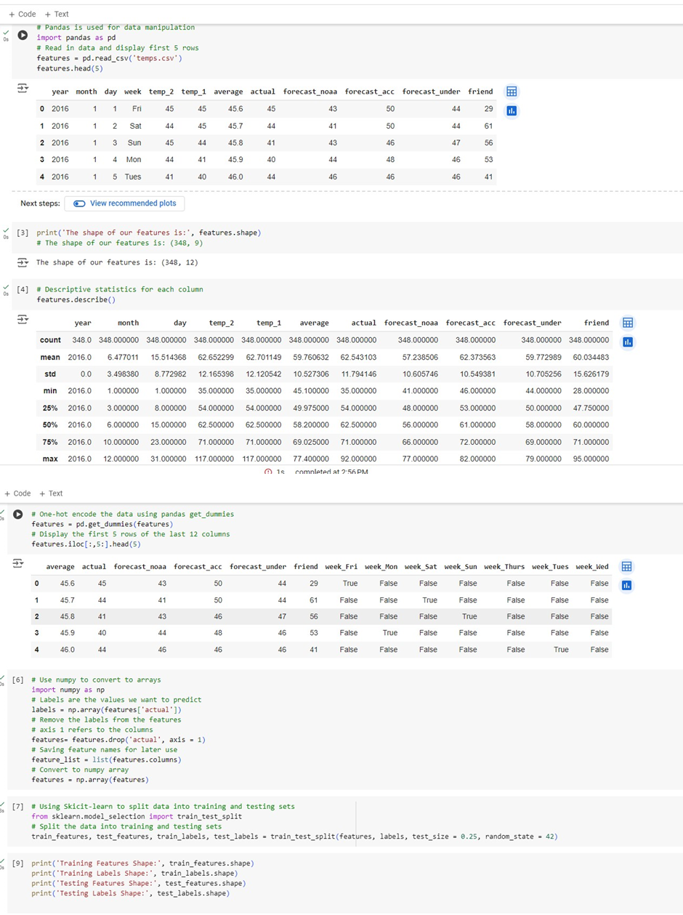

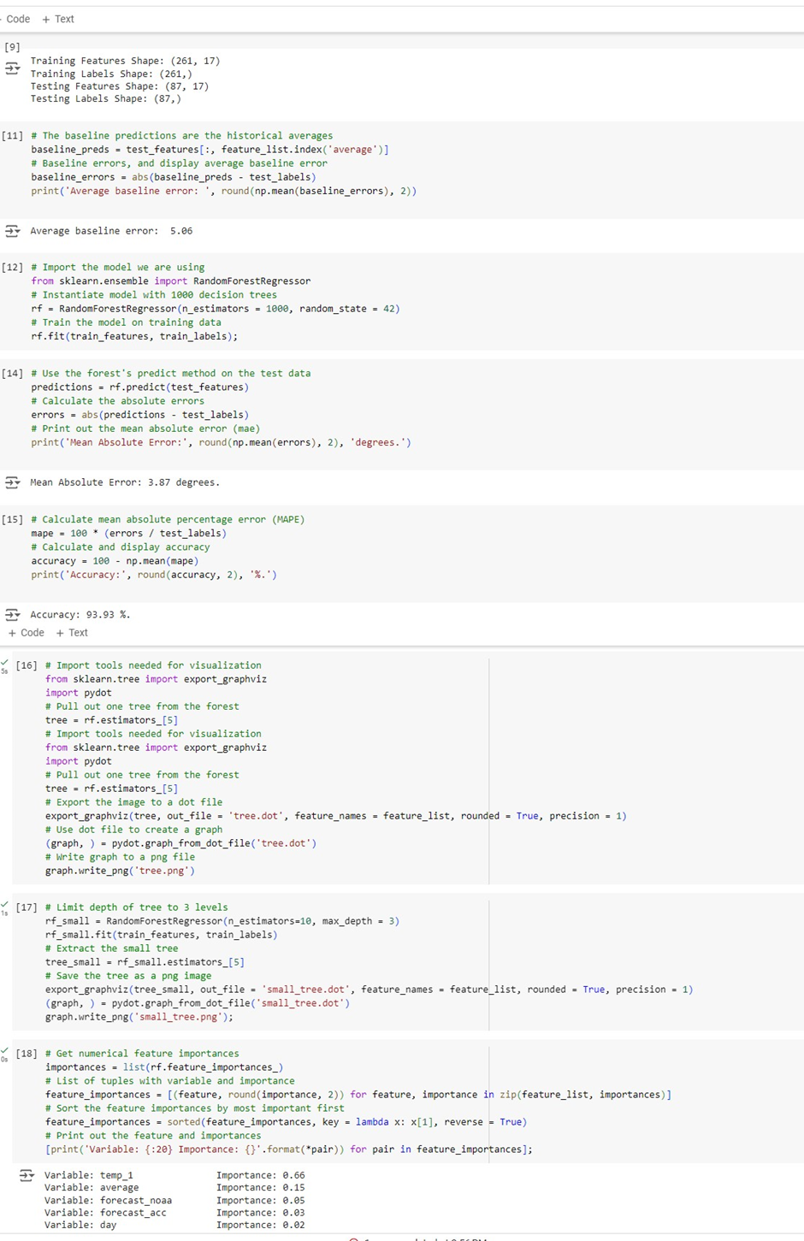

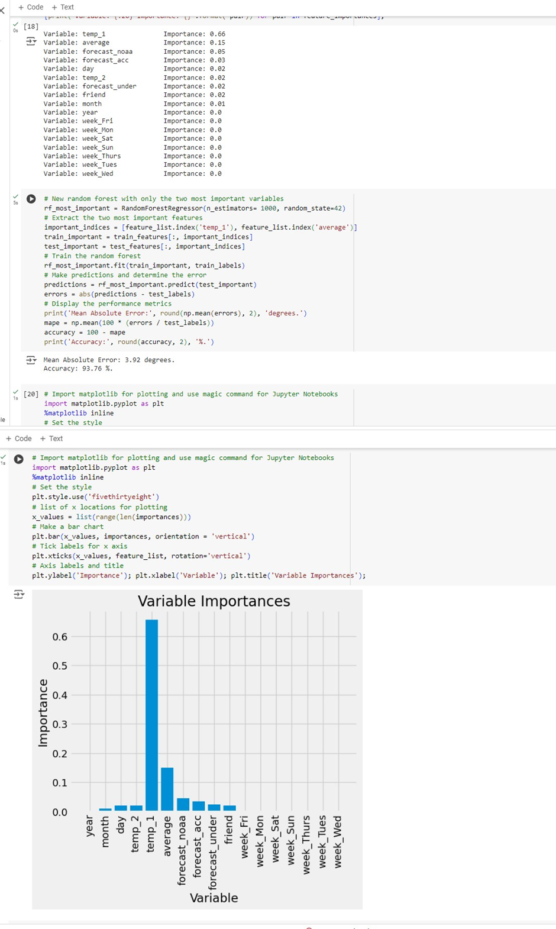

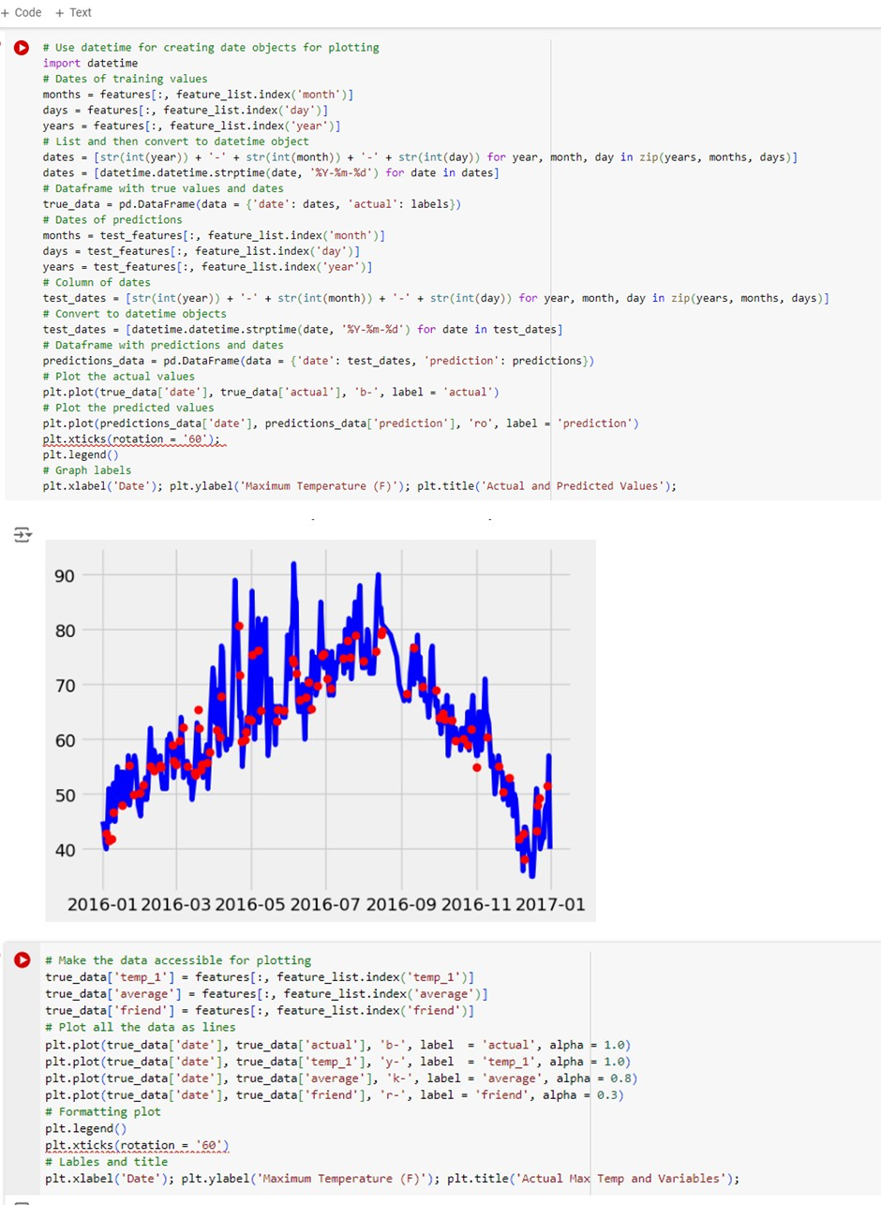

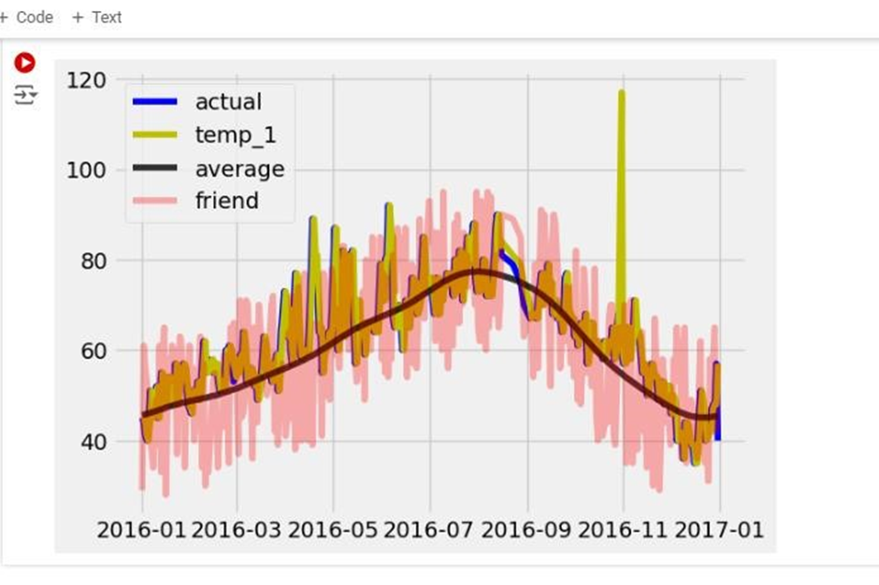

2.Implement Boosting ensemble method on a given dataset.

